|  |  |  |
| --- | --- | --- |
|  | | |
|  |  | |
|  |  |  |

### Media release

4 September, 2014

**STRICLY EMBARGOED UNTIL 12 NOON SEPTEMBER 4, 2014**

**Residential property value increases continue to slow**

The latest monthly QV Residential Price Movement Index shows that nationwide residential property values for August have increased 6.9% over the past year and 1.7% over the past three months.  This means they are now 15.8% above the previous market peak of late 2007. When adjusted for inflation the nationwide annual increase drops slightly to 5.2% and values remain below the 2007 peak by 0.8%.

 The Auckland market has increased 11.4% year on year and values are up 33.0% since 2007.  When adjusted for inflation values are up 9.7% over the past year and are 13.8% above the 2007 peak.

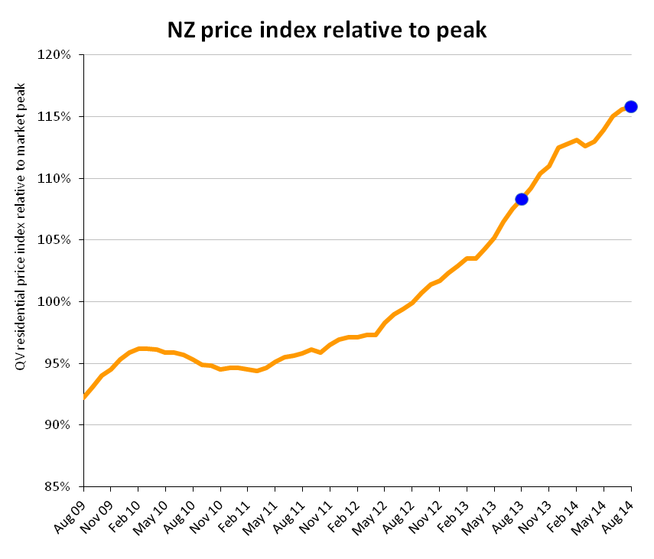

QV National Spokesperson Andrea Rush said, “Since September last year the growth rate of New Zealand residential property values has been slowing and this trend has continued over the past month.”

“Home values in Auckland, Christchurch and Tauranga are still increasing but at a slower rate than this time last year.”

“Hamilton and Dunedin home values have decreased slightly and Wellington values are continuing to show the downward trend seen over the past few months.”

“Sales volumes and home loan approvals are down year on year and interest rate rises, LVR restrictions and the upcoming election appear to be keeping the number of homes on the market low as well.”

**Auckland**

The Auckland region as a whole saw residential property values increase by 1.8% over the past three months and 11.4% year on year.

Auckland City Islands saw values increase the most, up 5.0% over the past three months; followed by Rodney – Hibiscus Coast up 3.4%; and Manukau – North West and Rodney District, both up 2.7%.

QV Valuer Bruce Wiggins said, “Winter has seen a continued reduction in transactions and listings are low across the Super City region. The upcoming election may also be a factor in the market being quiet as well as people wait to see the election result before making a decision.”

“Good properties are still attracting good money but if there are any issues with a property then it is likely to take longer to sell.”

“New builds are also selling well and attracting good prices. As there are no LVR restrictions on lending for new builds this may account for the stronger interest in this sector.”

**Hamilton and Tauranga**

Residential property values in Hamilton City have decreased slightly by 0.2% over the past three months, however they are 3.7% higher than in August last year.

Home values in South West Hamilton decreased 0.4% over the past three months; South East Hamilton is also down 0.5%, as is Hamilton - Central and North West down by 0.6% and values in Hamilton- North East remained the same.

Home values in the Matamata-Piako District are up 4.0% in the past three months and 5.7% year on year, but remain 3.9% below the previous peak of 2007.

QV Valuer Nicky Harris said, “Sales volumes have dropped off since late last year since the LVR speed limits and now we are seeing the typical trend of values starting to drop off too.”

“Properties in central, well established areas of Hamilton are selling well and holding value as there is a lack of supply.”

“Hamilton East, Hayes Paddock, St Andrews and Beerescourt remain popular.”

“In the North, the new subdivisions in Rototuna and Flagstaff are still selling well but there are more properties coming to the market now so demand is meeting supply.”

Residential Property values in Tauranga City have increased by 0.8% over the past three months and 5.1% year on year.

Values in the Western Bay of Plenty have decreased by 1.4% over the past three months and but remain 3.0% higher than in August last year.

QV Registered Valuer Mairi Macdonald said, “The Tauranga market is still steady with good demand for property, although sales volumes are down and there is slightly less activity in the entry level end of the market.”

“Suburbs like Bethlehem, Otumoetai and Pyes Pa are still selling well although sales volumes in Mt Maunganui and Papamoa have decreased.”

“We are seeing good demand from Aucklanders relocating to Tauranga at present because it’s more affordable.”

“New builds are popular due to the need for only 10% deposit instead of 20% for an existing home and new developments in Papamoa and Pyes Pa are still in demand.”

“In the Western Bay of Plenty, Omokoroa remains popular and the Kiwifruit orchards have recovered to pre-PSA value levels and those with the gold variety in particular are commanding premium prices.”

**Wellington**

Residential property values in the Wellington Region are still showing a slight downward trend down 0.5% over the past three months and values across the region as a whole are up 0.9% since August last year.

Home values in Wellington City have decreased slight 0.2% over the past three months, as have values in Wellington Central and South, down 0.5%. Wellington West is also down 1.0%; while Wellington North and East values have remained the same.

Lower Hutt home values have decreased by 2.1% in the past three months and 1.1% year on year. Upper Hutt has increased 0.9% over the past three months and home values there 0.3% below what they were this time last year.

QV Wellington Registered Valuer, Kerry Buckeridge said, “Home values across the Wellington region as a whole are now 1.3% below the 2007 peak and the Hutt Valley remains well behind.”

“Seven years is a long time not to see any value growth and a key factor is that Wellington does not have population growth to drive demand for homes.”

“Currently there are historically low levels of stock in the market and low interest from buyers. The upcoming election is likely to be a factor and could mean people are holding off making property decisions.”

“The current generation of new home buyers seem to find properties in need of renovation unappealing.”

“A full ‘doer-upper’ can still appeal to seasoned renovators’, but some first home buyers seem more likely to purchase a fully-finished apartment, than a standalone home that is in need of some work.”

**Christchurch and Dunedin**

Residential property values in Christchurch City have increased 1.1% over the past three months and they are 5.9% higher than in August last year.

Christchurch – Banks Peninsula has seen an increase in home values of 5.4% over the past three months while the Selwyn District increased by 2.1%. Home values in Christchurch South West increased 1.7% and while Christchurch Central and North is up 1.0% over the same period.

QV Valuer Daryl Taggart said, “The market is quiet but steady with relatively low activity at the moment - this may be related to the winter seasonal slowdown but we are no longer seeing multi-offer scenarios or buyers paying over the odds in the current market.”

“There is still plenty of construction going on but no longer the same high level of demand as we have seen in recent times.”

“Fewer properties are selling at auction and those that are often get passed in as people return to more traditional sale methods such as by negotiation or with a sale price.”

Home values in Dunedin City have decreased slightly by 0.4% over the past three months but are 1.3% higher than in August last year. The residential property market across the city is showing a slight downward trend over the past three months with values in all areas down slightly.

QV Registered Valuer Duncan Jack said, “Listings are fairly low across the city but there is moderate activity and reasonable demand for the properties that are on the market so many homes appear to be selling fairly quickly.”

“The greatest number of sales has been in the sub $300,000 range with 75% of all recent sales occurring at this level in recent times.”

“However there also remains relatively good demand for good quality well presented dwellings within the $350,000 plus range which appears to have been a trend during the past months and since the LVR restrictions.”

**Provincial centres**

Values in the provincial centres are variable while many are decreasing or flat there are a number of areas where residential property values are rising.

In the North Island, residential property values movements have been variable. Many of the districts and small towns have shown a decrease in value over the past three months including Palmerston North down 0.9%; New Plymouth down 0.3% and Rotorua down 0.8%.

However, some have seen home value increases including Whangarei up 0.3% and the Ruapehu District up 6.1% over the past three months.

In the South Island, residential property values movements are also variable. Home values have increased over the past three months by 6.0% in Gore; 3.5% in Central Otago; and 2.3% in the Clutha District. But they decreased by 1.6% in the Ashburton District; 2.1% in Invercargill City and 5.1% in the Grey District over the same period.

**For media enquiries and interviews, and for further information contact:**

Andrea Rush

QV National Spokesperson

Mobile: 021 866 152

Email: [andrea.rush@qv.co.nz](mailto:andrea.rush@qv.co.nz)

**For further specific comment on local areas:**

Hamilton. Nicky Harris 0274 696506

Tauranga. Mairi MacDonald 027 230 7281

Wellington. Kerry Buckeridge 021 476-287

Christchurch. Daryl Taggart 027 304 9815

Dunedin. Duncan Jack 027 213 7618

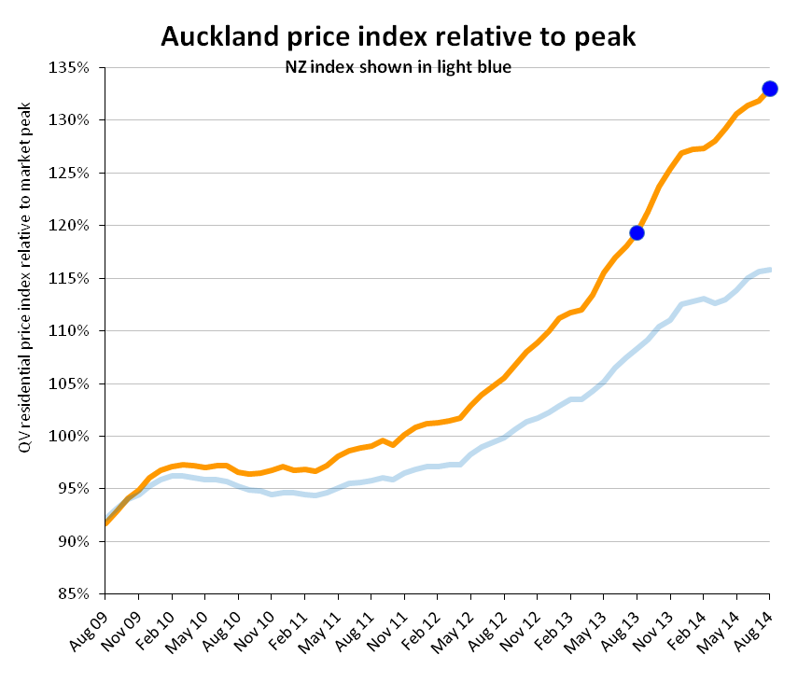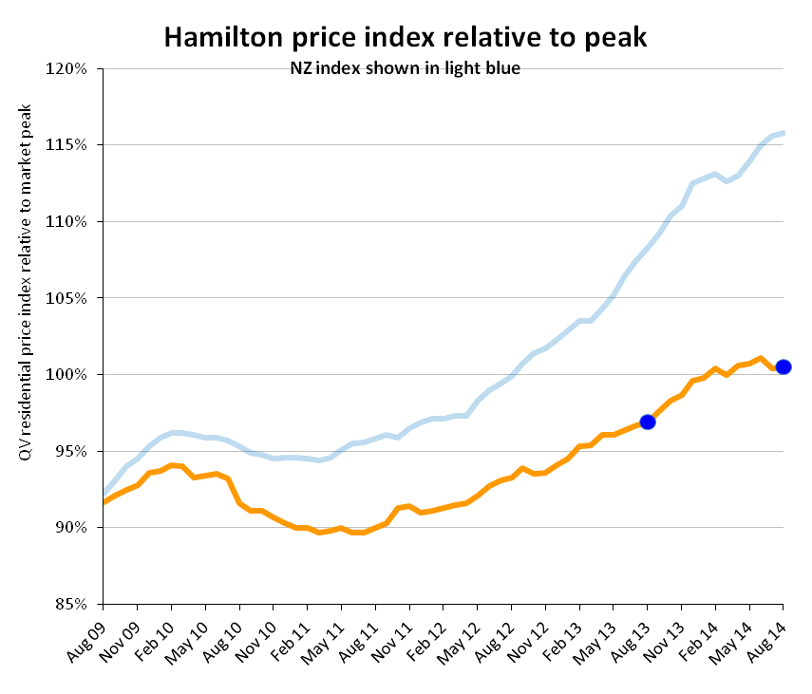

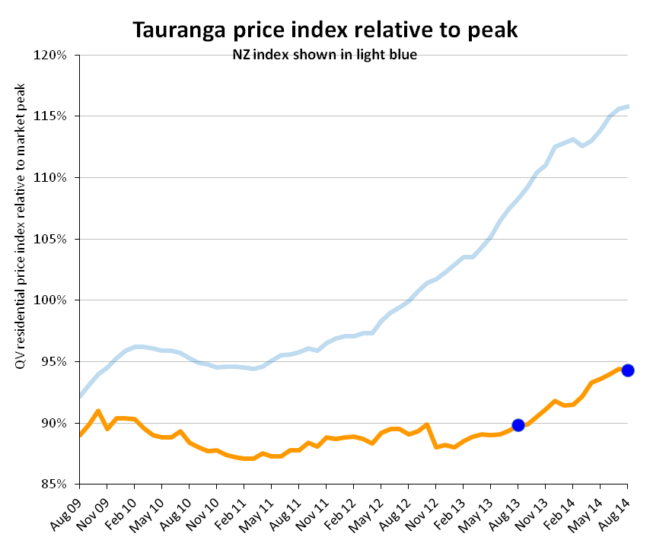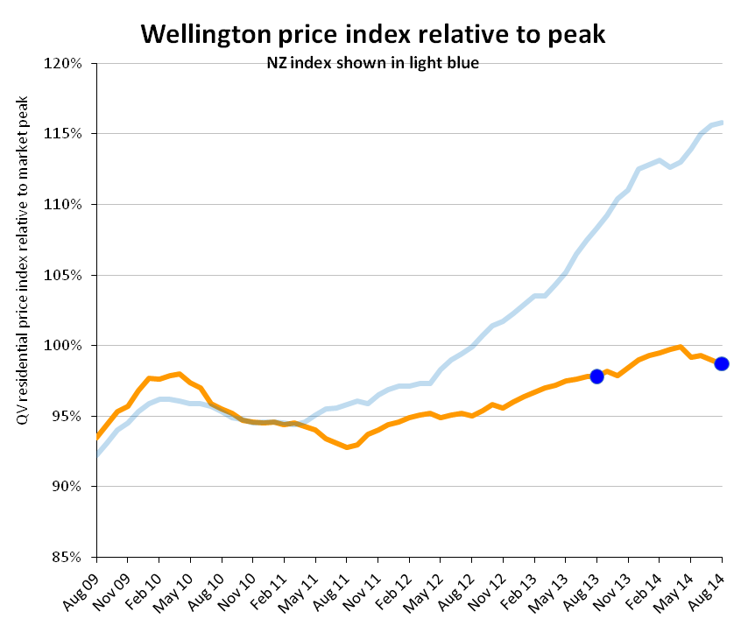

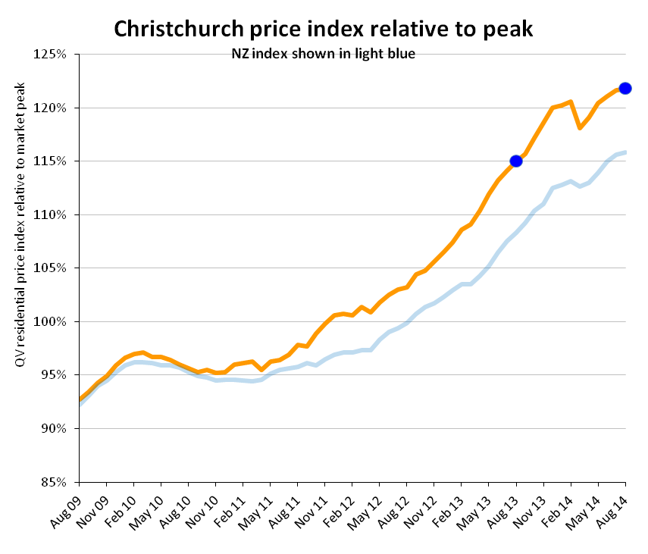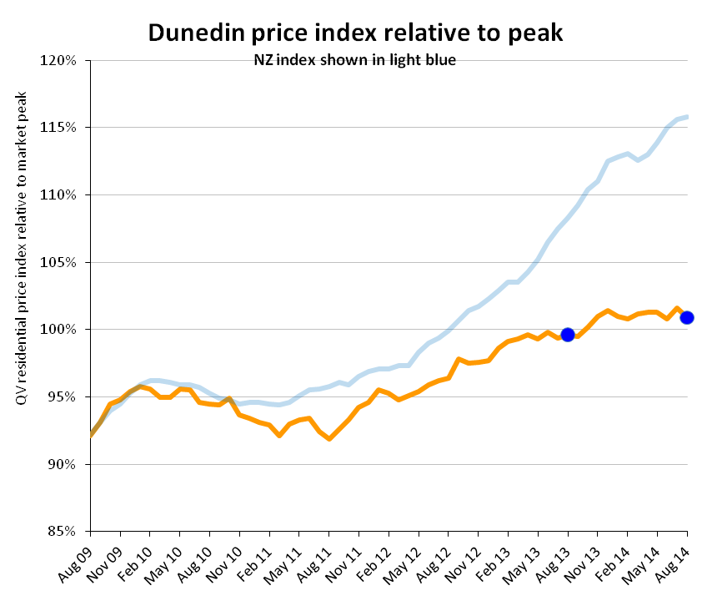

|  |  |  |  |  |  |
| --- | --- | --- | --- | --- | --- |
| **QV Residential Price Movement Index** | | |  |  |  |
| Time period: 31 Aug 2014 | |  |  |  |  |
|  |  |  |  |  |  |
|  | **Territorial authority** | **Average current value** | **12 month change%** | **3 month change %** | **Since 2007 market peak change %** |
|  | Far North | 300,458 | -3.3% | 0.8% | -24.6% |
|  | Whangarei | 337,977 | 2.2% | 0.3% | -14.7% |
|  | Kaipara | *330,825* | *5.5%* | *-0.4%* | *-16.6%* |
|  | Auckland – Rodney | 685,473 | 12.8% | 2.7% | 16.9% |
|  | Rodney - Hibiscus Coast | 684,496 | 13.5% | 3.4% | 16.5% |
|  | Rodney – North | 689,444 | 12.6% | 2.3% | 14.8% |
| #A | Auckland - North Shore | 857,990 | 11.4% | 1.0% | 33.0% |
|  | North Shore - Coastal | 991,684 | 12.2% | 1.3% | 31.6% |
|  | North Shore - Onewa | 678,511 | 10.2% | 1.0% | 36.8% |
|  | North Shore - North Harbour | 827,990 | 11.5% | 1.1% | 36.3% |
| #A | Auckland - Waitakere | 567,678 | 13.6% | 1.8% | 33.9% |
| #A | Auckland – City | 857,341 | 10.5% | 1.7% | 37.7% |
|  | Auckland City – Central | 758,518 | 9.6% | 0.1% | 33.2% |
|  | Auckland City – East | 1,069,375 | 10.7% | 1.8% | 34.2% |
|  | Auckland City – South | 766,079 | 10.6% | 2.2% | 42.3% |
|  | Auckland City – Islands | 779,560 | 12.9% | 5.0% | 21.9% |
| #A | Auckland – Manukau | 604,852 | 12.6% | 2.1% | 32.1% |
|  | Manukau – East | 805,150 | 11.8% | 1.7% | 35.1% |
|  | Manukau – Central | 461,753 | 12.9% | 2.1% | 22.8% |
|  | Manukau - North West | 496,589 | 13.8% | 2.7% | 34.4% |
| #A | Auckland – Papakura | 435,731 | 12.8% | 1.1% | 21.1% |
|  | Auckland – Franklin | 468,233 | 10.6% | 0.2% | 18.4% |
|  | Thames Coromandel | 505,148 | 2.4% | 0.0% | -13.1% |
|  | Hauraki | *227,261* | *-6.8%* | *-5.9%* | *-18.5%* |
|  | Waikato | 284,366 | 5.8% | -0.4% | -6.1% |
|  | Matamata Piako | 280,346 | 5.7% | 4.0% | -3.9% |
| # | Hamilton | 363,243 | 3.7% | -0.2% | 0.5% |
|  | Hamilton - North East | 458,703 | 4.3% | 0.0% | 2.0% |
|  | Hamilton - Central & North West | 339,202 | 2.5% | -0.6% | -5.2% |
|  | Hamilton - South East | 332,718 | 3.2% | -0.5% | -4.8% |
|  | Hamilton - South West | 319,224 | 3.0% | -0.4% | -6.7% |
|  | Waipa | 339,712 | 4.0% | 0.5% | 3.2% |
|  | Otorohanga | N/A | N/A | N/A | N/A |
|  | South Waikato | *126,381* | *-2.6%* | *-1.6%* | *-22.5%* |
|  | Waitomo | N/A | N/A | N/A | N/A |
|  | Taupo | 333,029 | -3.1% | -3.7% | -16.9% |
|  | Western BOP | 411,965 | 3.0% | -1.4% | -8.6% |
| # | Tauranga | 454,167 | 5.1% | 0.8% | -5.7% |
|  | Rotorua | 271,188 | -0.8% | -0.8% | -7.6% |
|  | Whakatane | 294,950 | -0.4% | 0.3% | -15.2% |
|  | Kawerau | N/A | N/A | N/A | N/A |
|  | Opotiki | *218,208* | *2.9%* | *6.2%* | *-23.2%* |
|  | Gisborne | 230,808 | 0.7% | 0.6% | -22.4% |
|  | Wairoa | *149,570* | *2.3%* | *-4.0%* | *-38.9%* |
|  | Hastings | 294,662 | -2.5% | -2.3% | -5.5% |
| # | Napier | 324,829 | 0.9% | 0.0% | -4.5% |
|  | Central Hawkes Bay | *211,646* | *8.7%* | *0.5%* | *-20.2%* |
|  | New Plymouth | 349,566 | 4.0% | -0.3% | 5.7% |
|  | Stratford | *203,462* | *6.1%* | *2.7%* | *-6.9%* |
|  | South Taranaki | 179,822 | -0.3% | 0.0% | -9.1% |
|  | Ruapehu | *136,793* | *-2.6%* | *6.1%* | *-24.2%* |
|  | Wanganui | 178,428 | -5.1% | -1.6% | -20.4% |
|  | Rangitikei | *144,688* | *-0.5%* | *-1.0%* | *-20.1%* |
|  | Manawatu | 241,289 | 0.4% | 0.6% | -5.1% |
| # | Palmerston North | 284,130 | -0.7% | -0.9% | -4.8% |
|  | Tararua | *148,499* | *-4.6%* | *-4.0%* | *-15.8%* |
|  | Horowhenua | 202,453 | 1.3% | -1.5% | -14.9% |
|  | Kapiti Coast | 372,688 | 1.9% | -0.7% | -2.7% |
| #W | Porirua | 372,969 | -0.8% | -0.3% | -2.4% |
| #W | Upper Hutt | 335,497 | -0.3% | 0.9% | -4.5% |
| #W | Hutt | 368,344 | -1.1% | -2.1% | -6.2% |
| #W | Wellington | 534,300 | 1.9% | -0.2% | 0.4% |
|  | Wellington - Central & South | 543,169 | 1.9% | -0.5% | -3.1% |
|  | Wellington – East | 574,925 | 2.6% | 0.0% | -0.2% |
|  | Wellington – North | 471,219 | 2.3% | 0.0% | 1.1% |
|  | Wellington – West | 606,772 | -0.1% | -1.0% | -0.1% |
|  | Masterton | 239,799 | 1.0% | 2.2% | -16.1% |
|  | Carterton | *268,162* | *4.5%* | *3.0%* | *-3.8%* |
|  | South Wairarapa | *306,794* | *6.1%* | *2.9%* | *-9.3%* |
|  | Tasman | 412,548 | 2.6% | -0.9% | 2.7% |
| # | Nelson | 402,701 | 1.4% | 0.3% | 5.1% |
|  | Marlborough | 346,737 | -0.8% | 0.1% | -11.1% |
|  | Kaikoura | N/A | N/A | N/A | N/A |
|  | Buller | *207,155* | *-7.3%* | *-1.6%* | *0.8%* |
|  | Grey | *214,594* | *-1.4%* | *-5.1%* | *-12.2%* |
|  | Westland | *232,101* | *1.8%* | *0.5%* | *-3.3%* |
|  | Hurunui | *342,363* | *2.5%* | *0.4%* | *9.5%* |
|  | Waimakariri | 405,124 | 4.4% | 0.0% | 26.5% |
| # | Christchurch | 462,086 | 5.9% | 1.1% | 21.8% |
|  | Christchurch – East | 343,957 | 3.1% | 0.1% | 11.1% |
|  | Christchurch – Hills | 623,448 | 2.0% | -0.4% | 12.7% |
|  | Christchurch - Central & North | 540,843 | 7.4% | 1.0% | 22.1% |
|  | Christchurch - Southwest | 443,648 | 9.0% | 1.7% | 30.7% |
|  | Christchurch - Banks Peninsula | *481,149* | *-2.1%* | *5.4%* | *0.2%* |
|  | Selwyn | 505,405 | 6.7% | 2.1% | 35.5% |
|  | Ashburton | 315,670 | 3.9% | -1.6% | 12.8% |
|  | Timaru | 281,954 | 3.5% | 0.1% | 12.4% |
|  | MacKenzie | *283,958* | *0.4%* | *-2.6%* | *-0.9%* |
|  | Waimate | *196,247* | *3.4%* | *0.0%* | *4.1%* |
|  | Waitaki | 219,998 | 4.9% | 0.0% | -3.7% |
|  | Central Otago | 324,940 | 7.0% | 3.5% | 2.5% |
|  | Queenstown Lakes | 667,584 | 3.7% | -0.2% | -2.9% |
| # | Dunedin | 288,920 | 1.3% | -0.4% | 0.9% |
|  | Dunedin - Central & North | 296,610 | 0.7% | -0.1% | -1.7% |
|  | Dunedin - Peninsular & Coastal | *265,138* | *-0.7%* | *-1.4%* | *-2.1%* |
|  | Dunedin – South | 279,804 | 2.9% | -0.3% | -2.0% |
|  | Dunedin – Taieri | 299,251 | 1.5% | -0.2% | 1.8% |
|  | Clutha | *166,185* | *3.7%* | *2.3%* | *-8.3%* |
|  | Southland | 205,669 | 3.2% | -0.6% | -10.7% |
|  | Gore | *186,263* | *6.5%* | *6.0%* | *6.0%* |
| # | Invercargill | 205,252 | 0.4% | -2.1% | -6.9% |
|  |  |  |  |  |  |
|  | Auckland Area | 726,627 | 11.4% | 1.8% | 33.0% |
|  | Wellington Area | 449,838 | 0.9% | -0.5% | -1.3% |
| # | Main Urban Areas | 559,890 | 8.4% | 1.8% | 21.9% |
|  | **Total NZ** | 479,967 | **6.9%** | **1.7%** | **15.8%** |
|  | | | |  |  |
| **Notes on the above data:** | | | |  |  |
| 1. The information included in the above table is based on the monthly property value index driven by CoreLogic. This index is calculated based on the sales data entered into CoreLogic's system in the previous 3 month period. For example, information for the period ending June will be calculated based on sales entered between April 1 and June 30. | | | | | |
| 2. The average current value is the average (mean) value of all developed residential properties in the area based on the latest index. It is not an average or median sales price, as both of those only measure what happens to have sold in the period. | | | | | |
| 3. The percentage change over three months, twelve months and since the 2007 market peak are based on the change in the property value index between that time and the current. | | | | | |
| 4. Any of the statistical data shown in italics are calculated based on a sample set of data that is less than the recommended minimum. These results should be used with caution. Those showing N/A had too few sales to generate an index | | | | | |